This is a verification document created to verify the actual working of application Locker.com(Simplilearn Project 1) is meeting the requirement.Created by Roshan Jha.

* File location “C:\\Users\\ASUS\\Dropbox\\My PC (LAPTOP-811NLRVE)\\Desktop\\file handling” before application is in running mode.

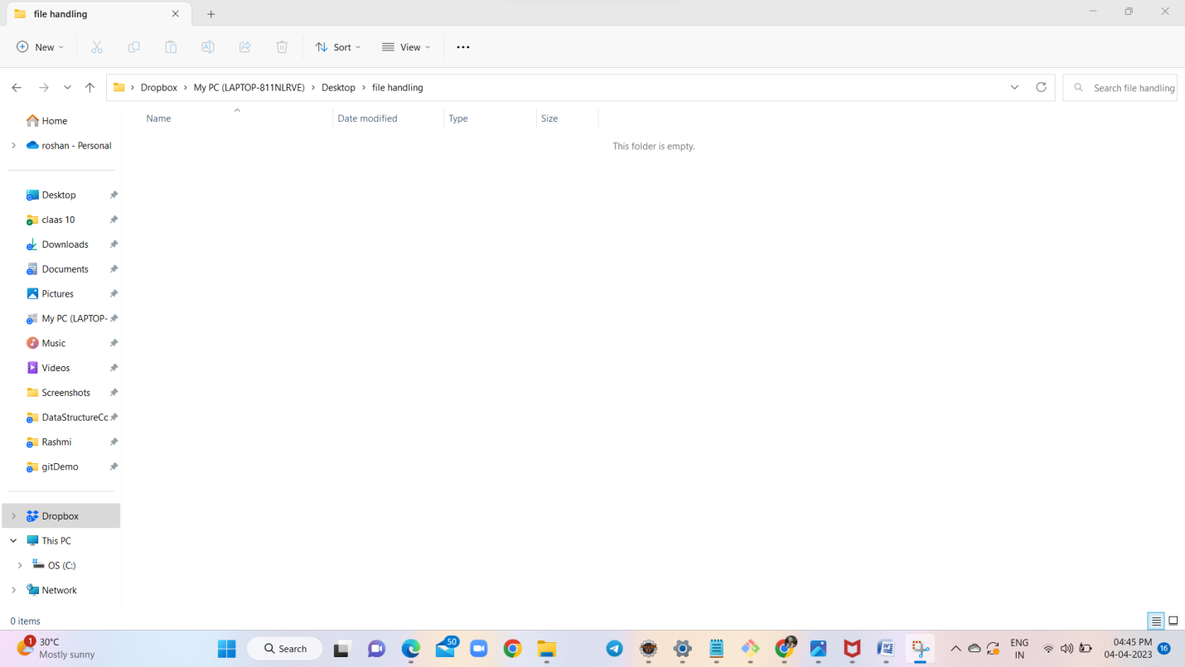

* Application WelcomeScreen.

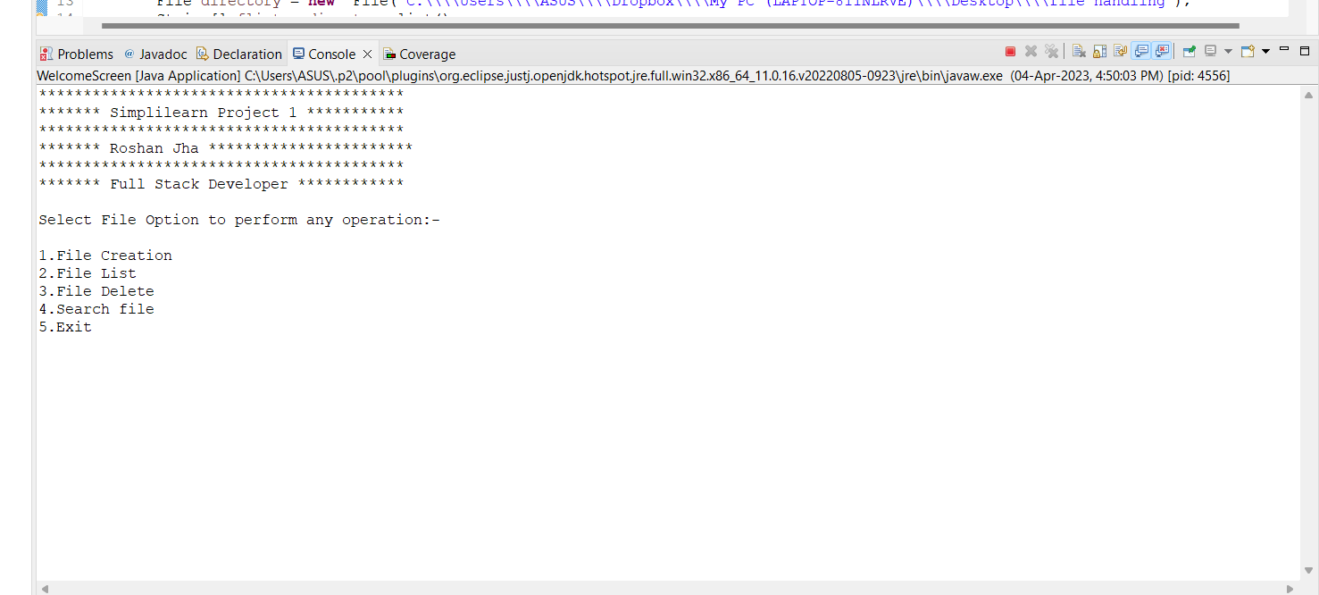

* Application running with option 1.(Under File creation mode)

Actual ouput: (Application WelcomeScreen)

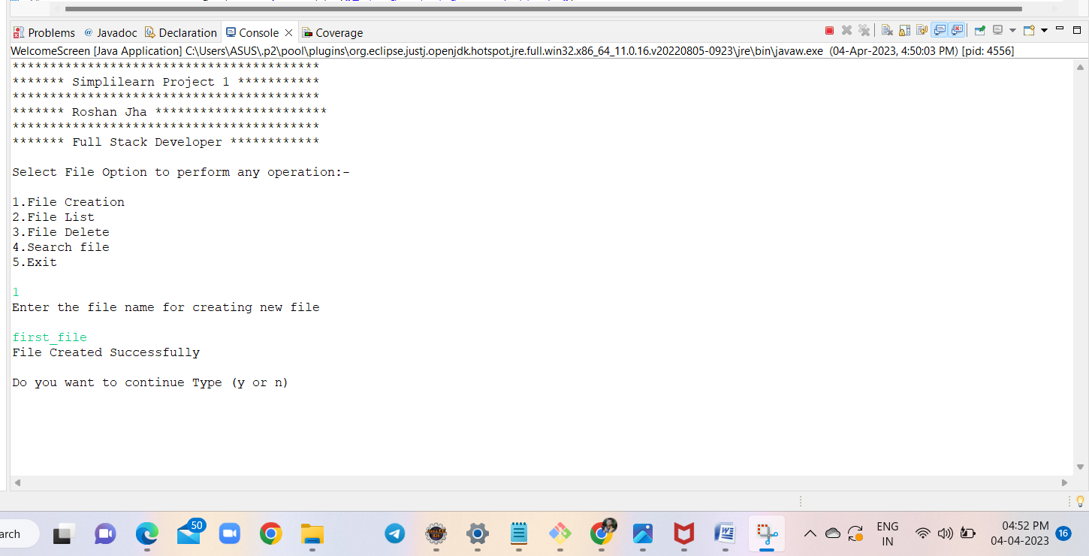

Requirement: (File reflecting under directory “C:\\Users\\ASUS\\Dropbox\\My PC (LAPTOP-811NLRVE)\\Desktop\\file handling” )

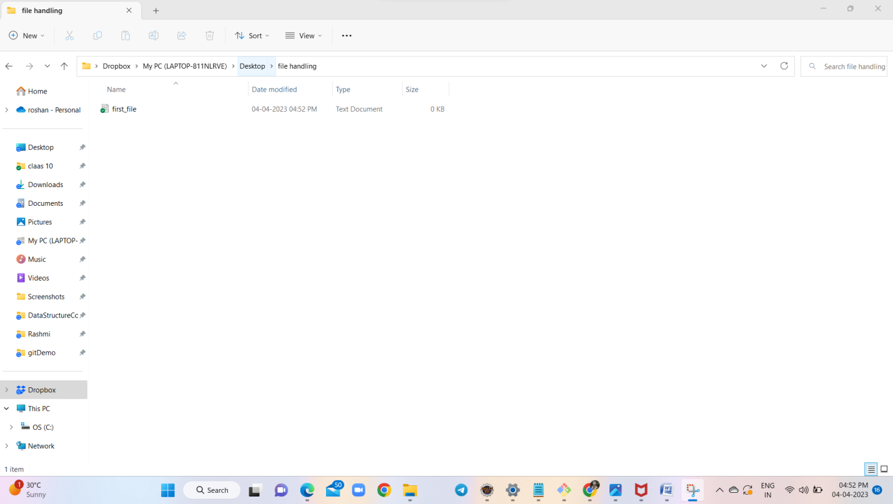

Conclusion : PASS

* Creating four files in application Window

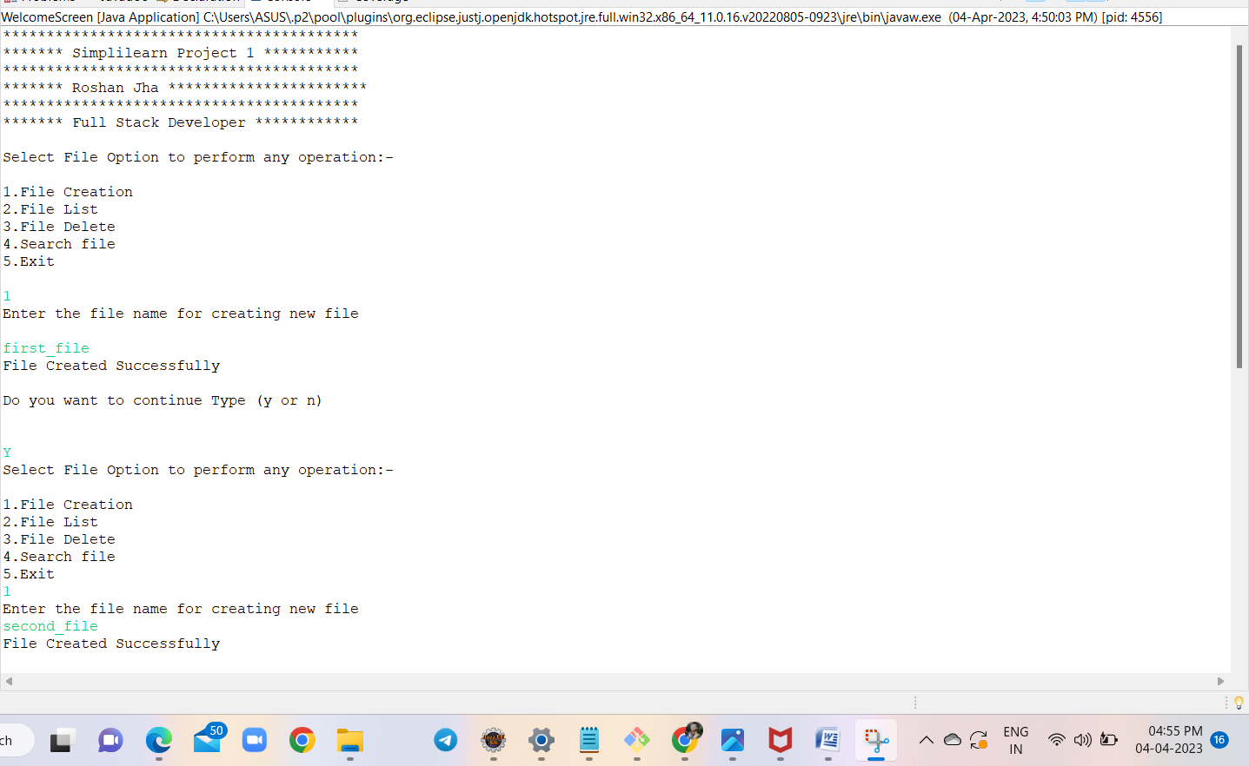

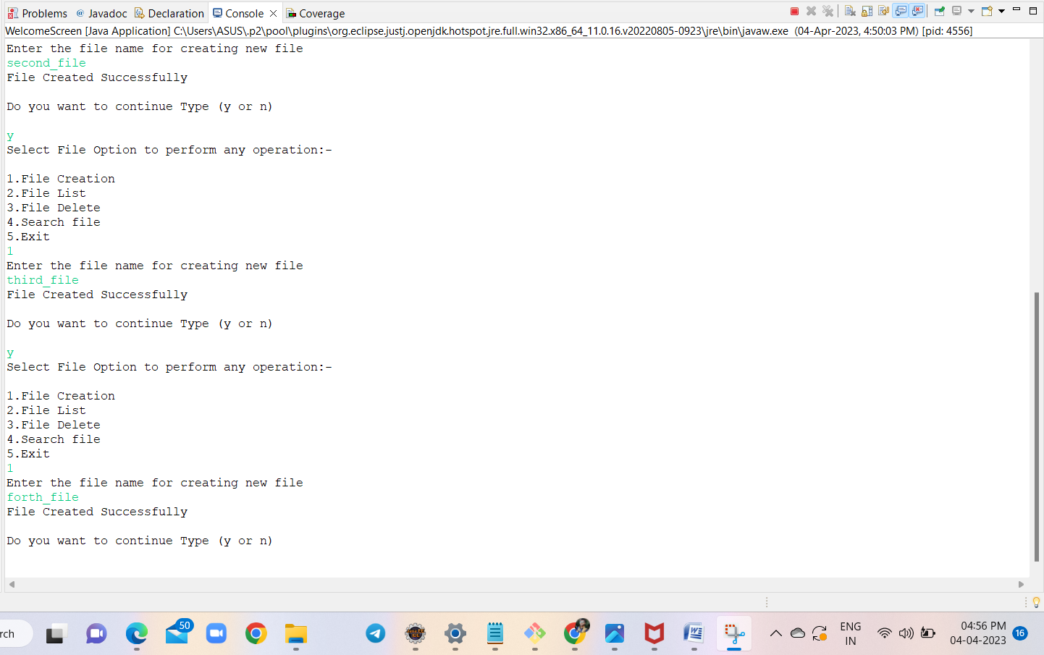

(File reflecting under directory “C:\\Users\\ASUS\\Dropbox\\My PC (LAPTOP-811NLRVE)\\Desktop\\file handling” )

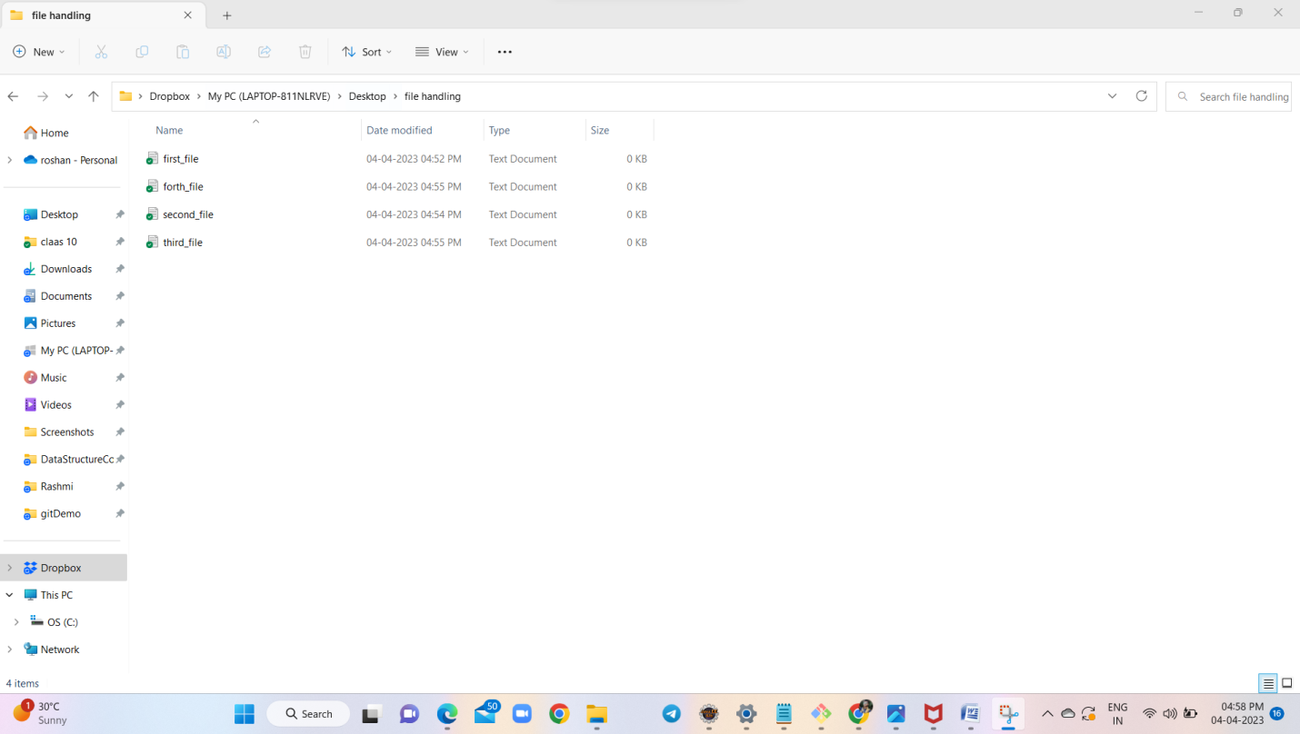

* Application running with option 2.(Under File List mode)

Actual output: (Application WelcomeScreen)

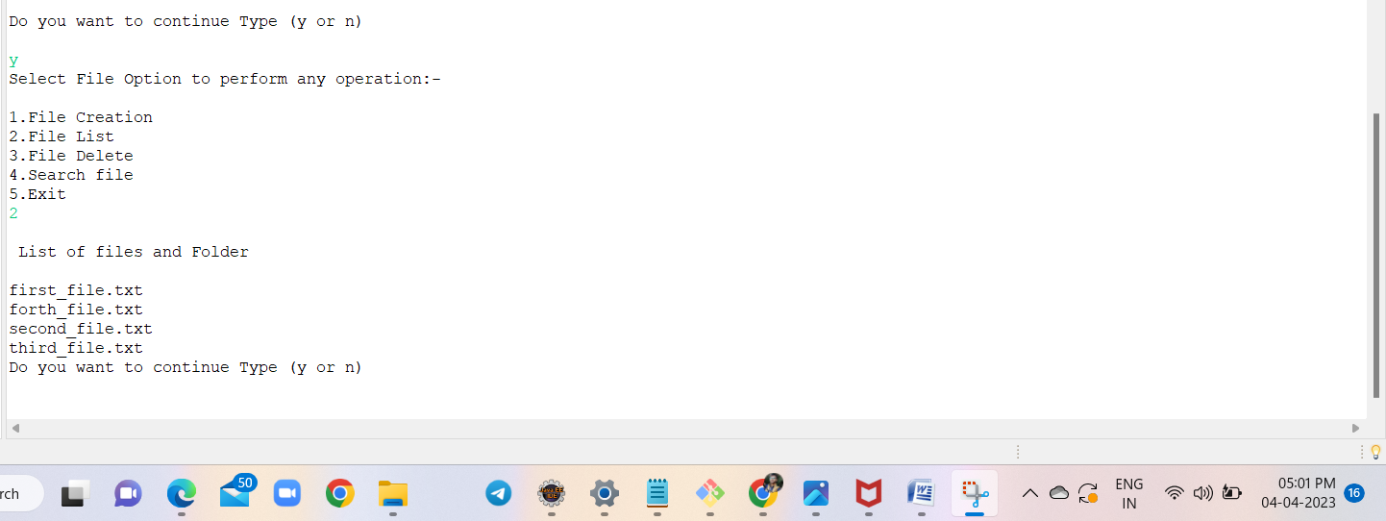

(File reflecting under directory “C:\\Users\\ASUS\\Dropbox\\My PC (LAPTOP-811NLRVE)\\Desktop\\file handling” )



Conclusion: Pass

* Application running with option 4.(Under File Search mode)
* Actual output: (Application WelcomeScreen)

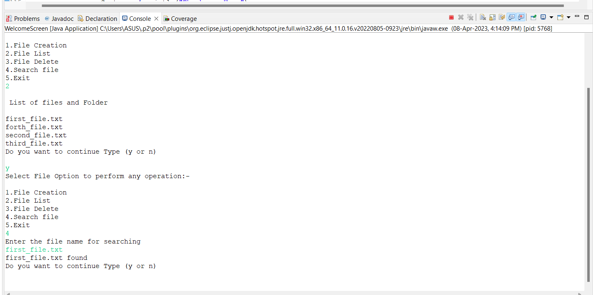

Conclusion: Pass

* Application running with option 3.(Under File Delete mode)
* Actual output: (Application WelcomeScreen)

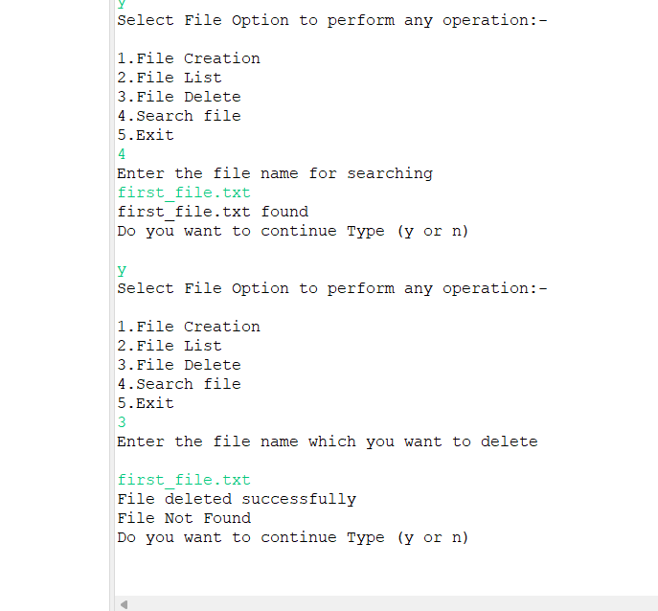

(File reflecting under directory “C:\\Users\\ASUS\\Dropbox\\My PC (LAPTOP-811NLRVE)\\Desktop\\file handling” )

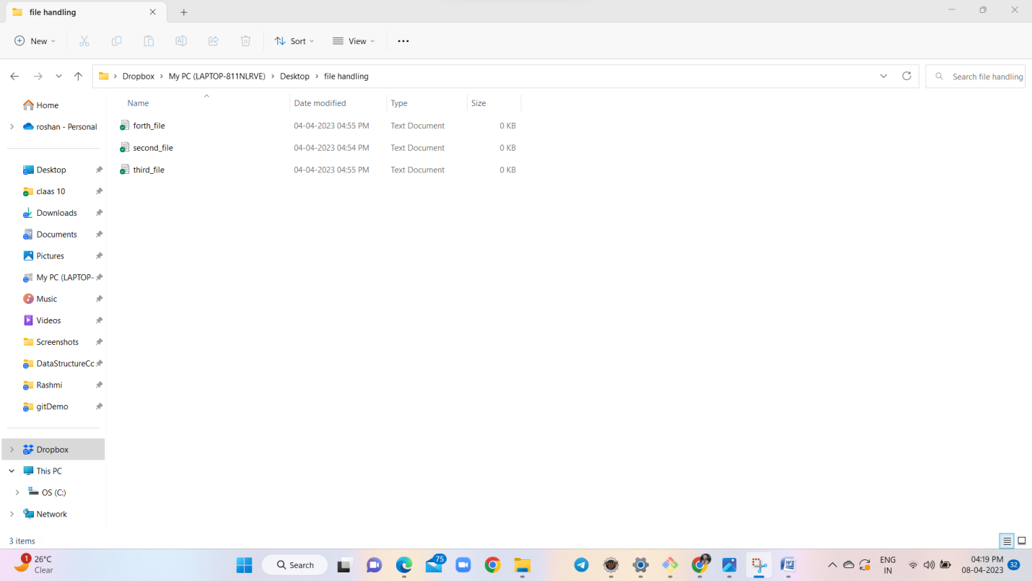

Conclusion: Pass

Exiting Application home page:

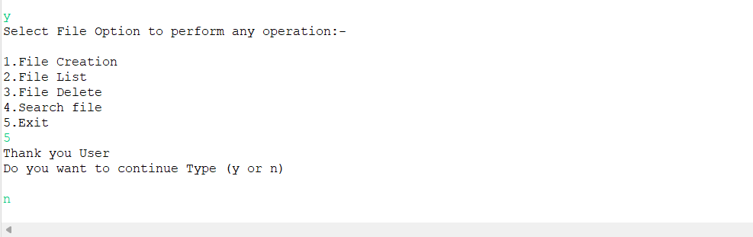

Conclusion: Pass